

TEAM 4.- MEDICAL SERVICES

1.Galarza Andres

2. Jaramillo jean

3. Titoaña Leslie

4. Villavicencio Alina

5. Yánez Erick

**Report**

**Team Organization**

| Galarza Andres | **Code,database** |
| --- | --- |
| Jaramillo jean | **Class Diagram,code** |
| Titoaña Leslie | **Class Diagram,code** |
| Villavicencio Alina | **Class Diagram, database** |
| Yánez Erick | **Code,database** |

**Problem Solution**

This hospital application project will help us organize all patients in a more orderly way, since when someone goes to register in the application, they will ask for their personal data such a: name, last name, age, gender, email, address, phone, and all this data will be saved in our Patient database.

And if we already need to remove the patient from our database, we only need to press the delete button, which will ask us to enter the patient's name to be identified and eliminated.

***CLASS DIAGRAM***

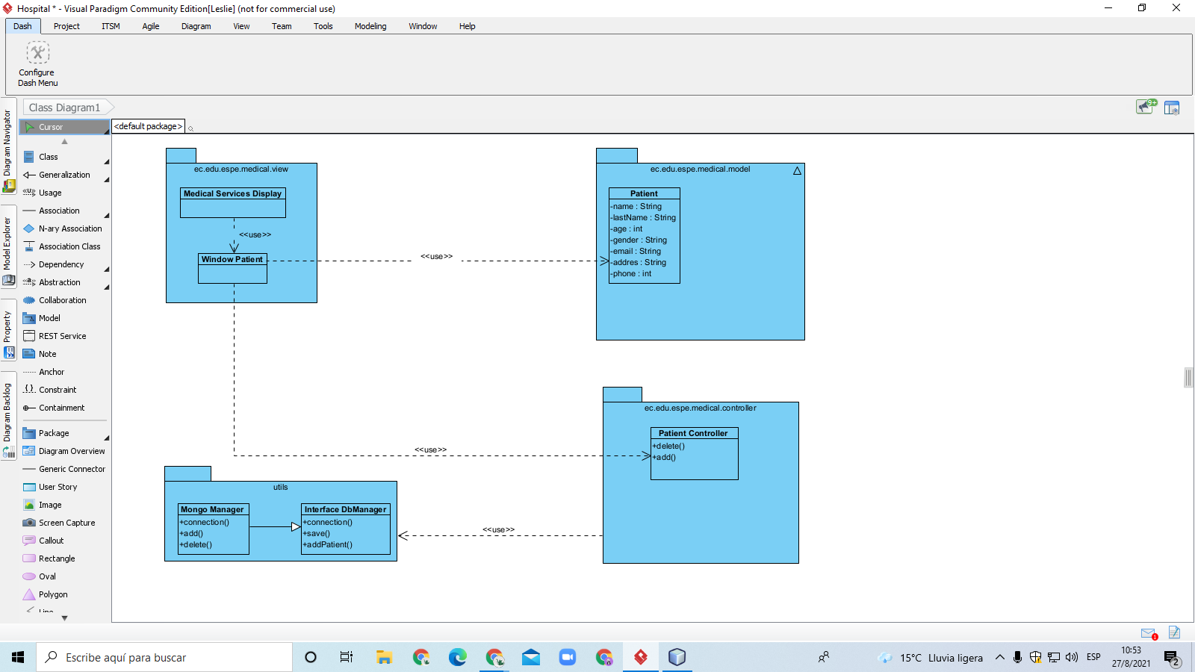

-Database (json)

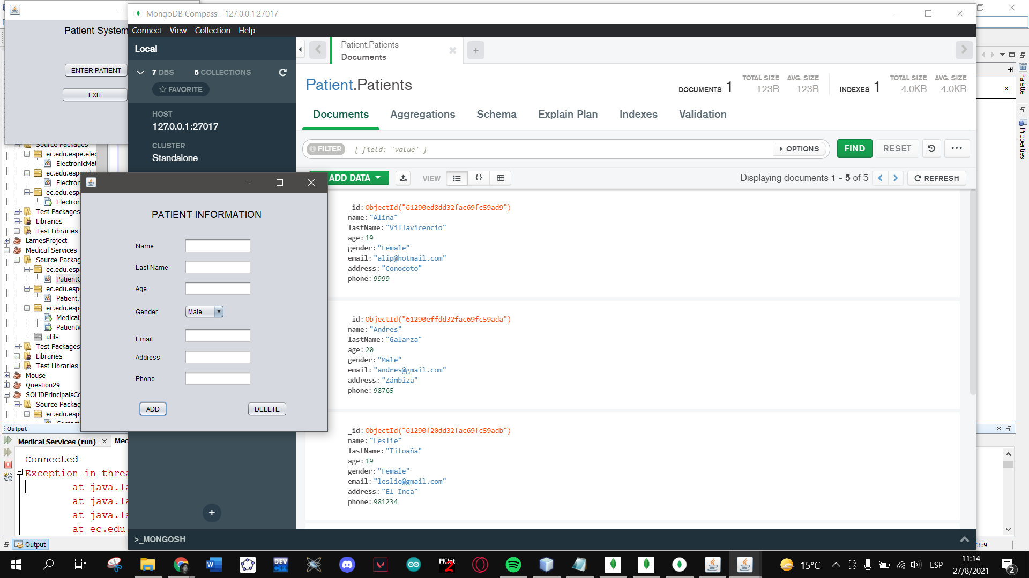

-Code

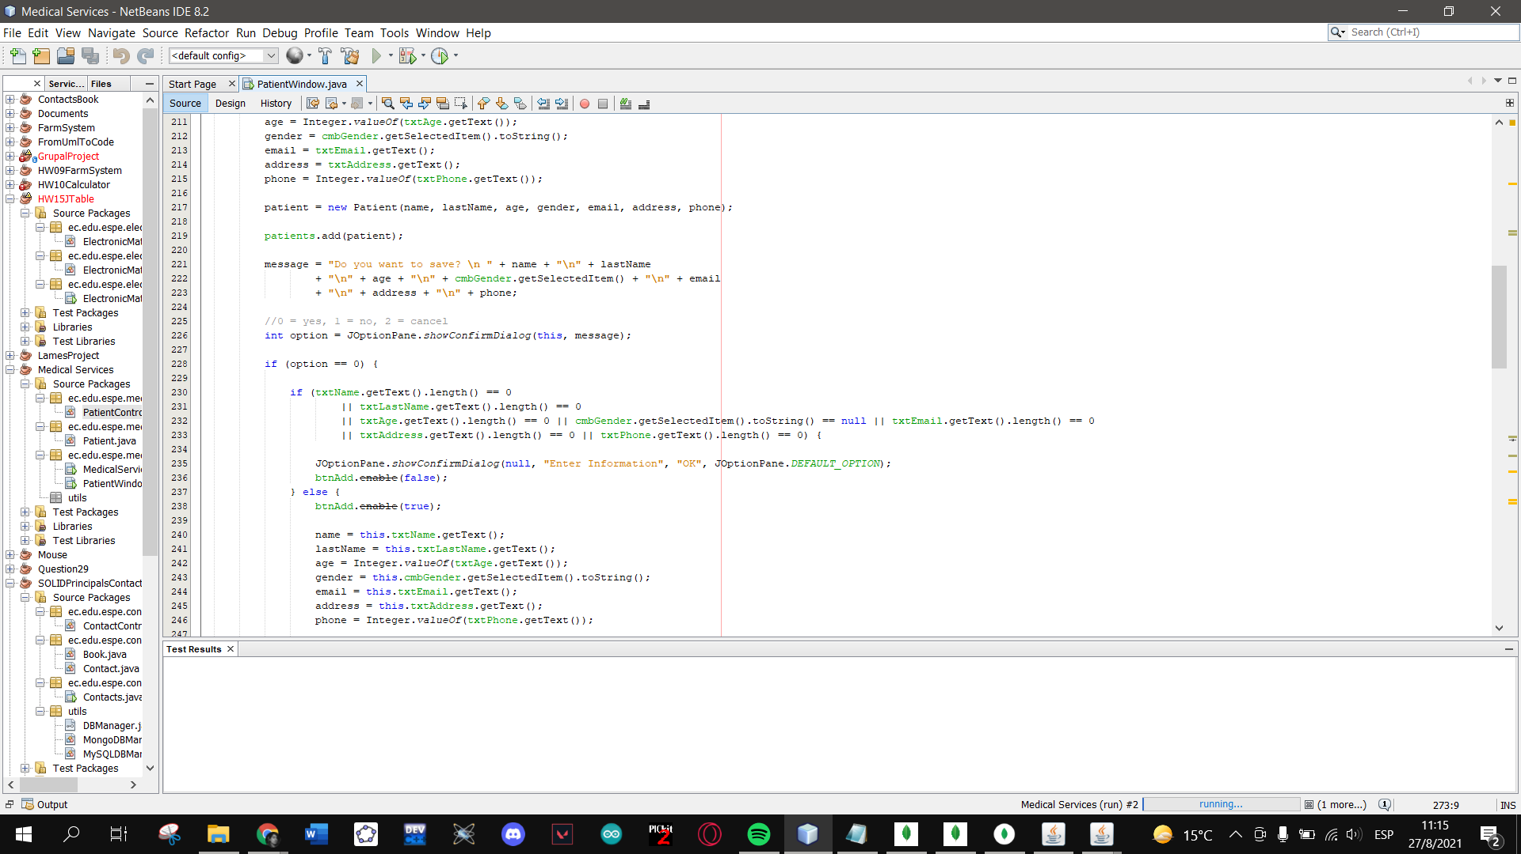

-Execution

